Windows Firewall Configuration - Truly Block EVERYTHING...
Now, we're going to use Windows Firewall Control for easier management. Configure exactly as depicted in the screenshots...

1. Profiles:

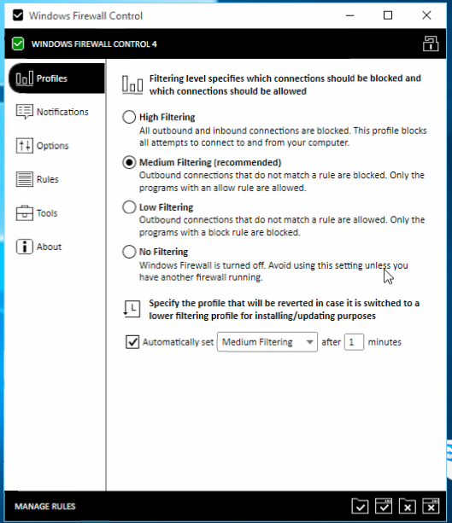
This ensures everything you haven't allowed, will be blocked. High Blocks EVERYTHING, no matter what, as if you disabled your internet. Also, there's a 1 minute option. You could quickly lower/deactivate Firewall, but make sure it comes back up.

2. Notifications

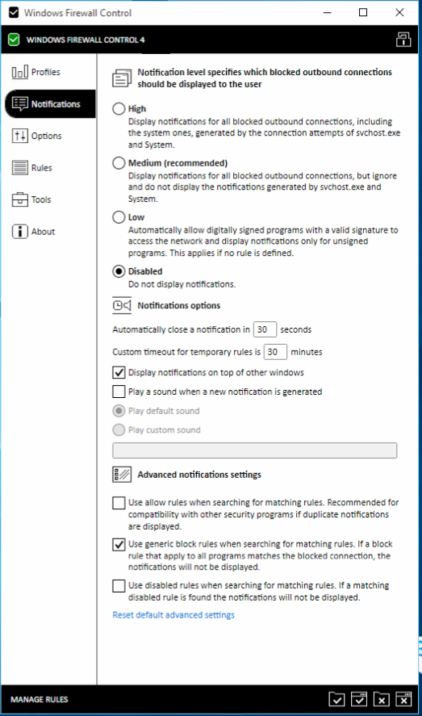
Altogether, we disable notifications and any leniency. You'll be bombarded otherwise.

3.Options

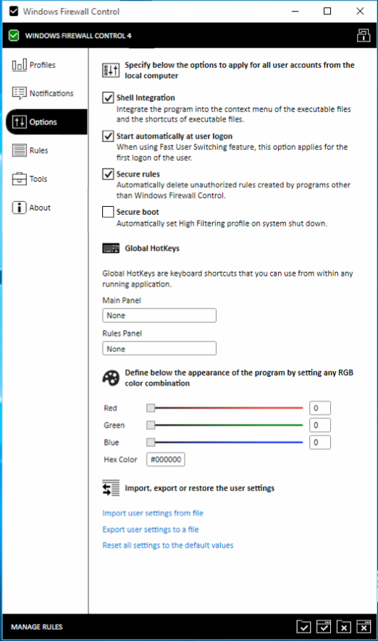
Easy Right Click to Whitelist, Disable anything else from tampering with rules, and autostart WFC. (I didn't use Secure Boot, as it would kill my TeamViewer on reboot, as you have to manually downgrade to Medium from High every restart if you enable this).

4. Rules

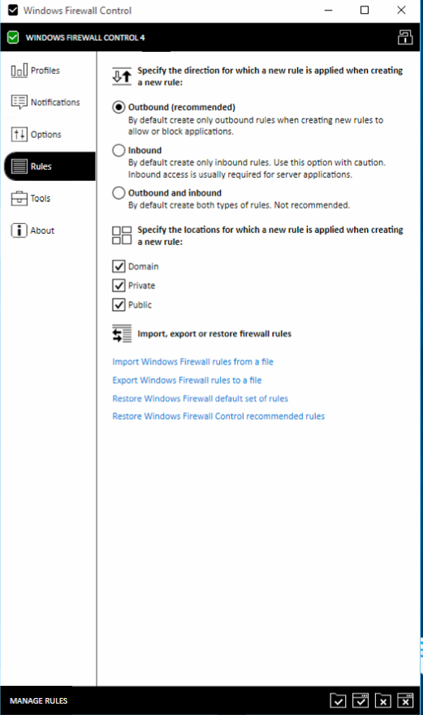
Apply for all connection profile types, and let's not blanket allow Incoming Connections. Most apps don't need them.

5. Tools

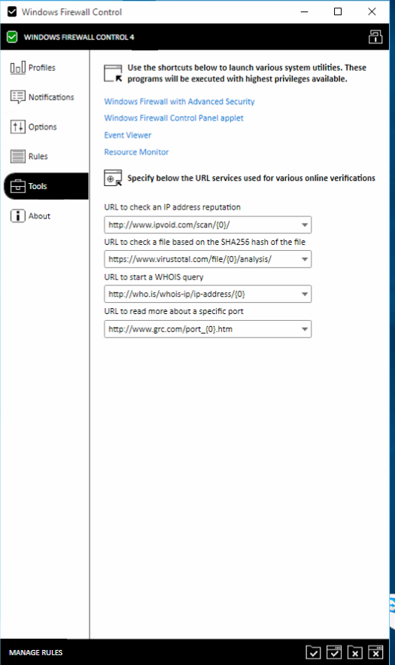
Leave this section alone.

6. About

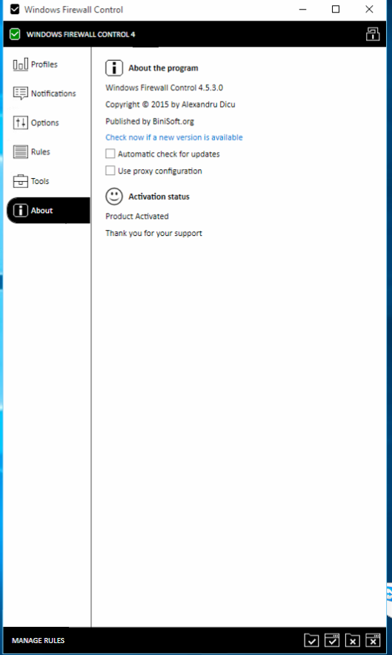
I disabled the auto-update.

Whitelisting Programs:
Spoiler:
Now, find apps that you want to use the internet, right click them, and whitelist them:
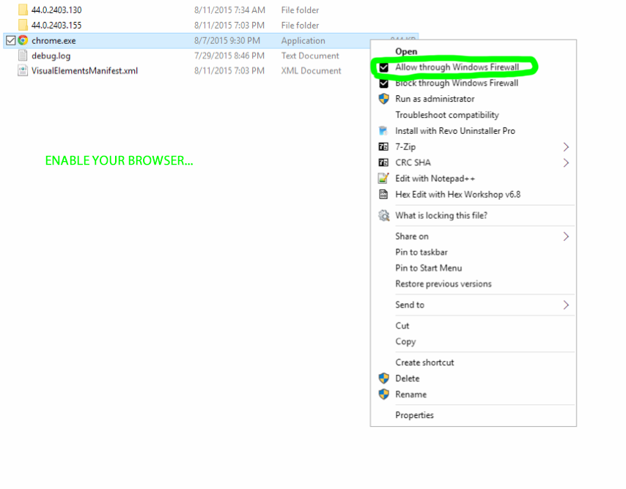
Notes:
1. Be warned that this setup is for someone with the time and knowledge to put up with apps, network services, the entire internet, etc, not working, and to figure out what is needed to whitelist. There is a log feature in WFC that will help you view connections, but it's mostly trial and error if you're trying to unblock something like Windows Update (in case by registry above doesn't work for you).
2. Don't blindly enable WFC Recommended Rules. It allows the Windows Store to talk to the internet, in case you don't want that.
3. I tested with a fully activated WFC. You will not have Notification Levels to control if not activated.
4. This may cause lower level services and networking to fail (even LAN Drives). It may require more effort than simply right click to whitelist to handle said services.
5. Some apps may have multiple exe files that need whitelisted to fully function. You'll likely only need to worry about EXE files.
6. Unless Microsoft compromises their own Firewall Software (which is terrible as it should do what it is told, and the Pro and up version are supposed to be Enterprise grade (*cough*), this should kill all possibilities for talking to MS, except those you knowingly (or unknowingly, with too permissive whitelisting) allow via WFC.

Last edited by CODYQX4; 24 Aug 2015 at 15:25.

